**Unit 5**

**Q.1) Create an application to implement class and functional component in ReactJS.**

**ClassComponent.js**

import React, { Component } from "react";

class ClassComponent extends Component {

  constructor(props) {

    super(props);

    this.state = {

      message: "Hello from Class Component!",

    };

  updateMessage = () => {

    this.setState({ message: "Class Component Message Updated!" });

  };

  render() {

    return (

      <div

        style={{ border: "1px solid black", padding: "10px", margin: "10px" }}

      >

        <h2>{this.state.message}</h2>

        <button onClick={this.updateMessage}>Update Message</button>

      </div>

    );

  }

}

export default ClassComponent;

**FunctionComponent.js**

import React, { useState } from 'react';

const FunctionComponent = () => {

const [message, setMessage] = useState('Hello from Functional Component!');

const updateMessage = () => {

    setMessage('Functional Component Message Updated!');

  };

  return (

    <div style={{ border: '1px solid black', padding: '10px', margin: '10px' }}>

      <h2>{message}</h2>

      <button onClick={updateMessage}>Update Message</button>

    </div>

  );

};

export default FunctionComponent;

**App.js**

import React from 'react';

import './App.css';

import ClassComponent from './ClassComponent';

import FunctionComponent from './FunctionComponent';

function App() {

  return (

    <div className="App">

      <h1>React Components Demo</h1>

      <ClassComponent />

      <FunctionComponent />

    </div>

  );

export default App;

**App.css**

.App {

  text-align: center;

  font-family: Arial, sans-serif;

}

h1 {

  color: #4caf50;

}

button {

  background-color: #008cba;

  color: white;

  border: none;

  padding: 10px 15px;

  margin-top: 10px;

  cursor: pointer;

  border-radius: 5px;

button:hover {

  background-color: #005f73;

}

**Index.js**

import React from 'react';

import ReactDOM from 'react-dom/client';

import './index.css';

import App from './App';

import reportWebVitals from './reportWebVitals';

const root = ReactDOM.createRoot(document.getElementById('root'));

root.render(

  <React.StrictMode>

    <App />

  </React.StrictMode>

);

reportWebVitals();

Ouptut :

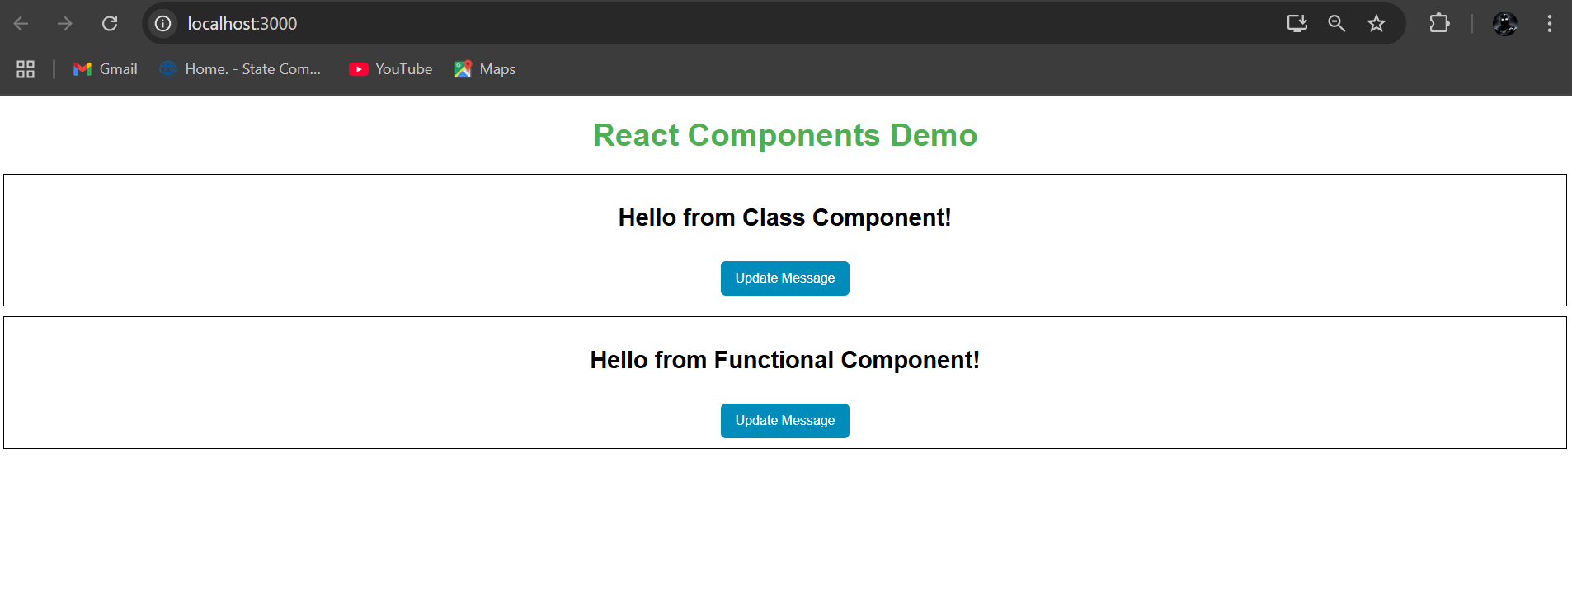

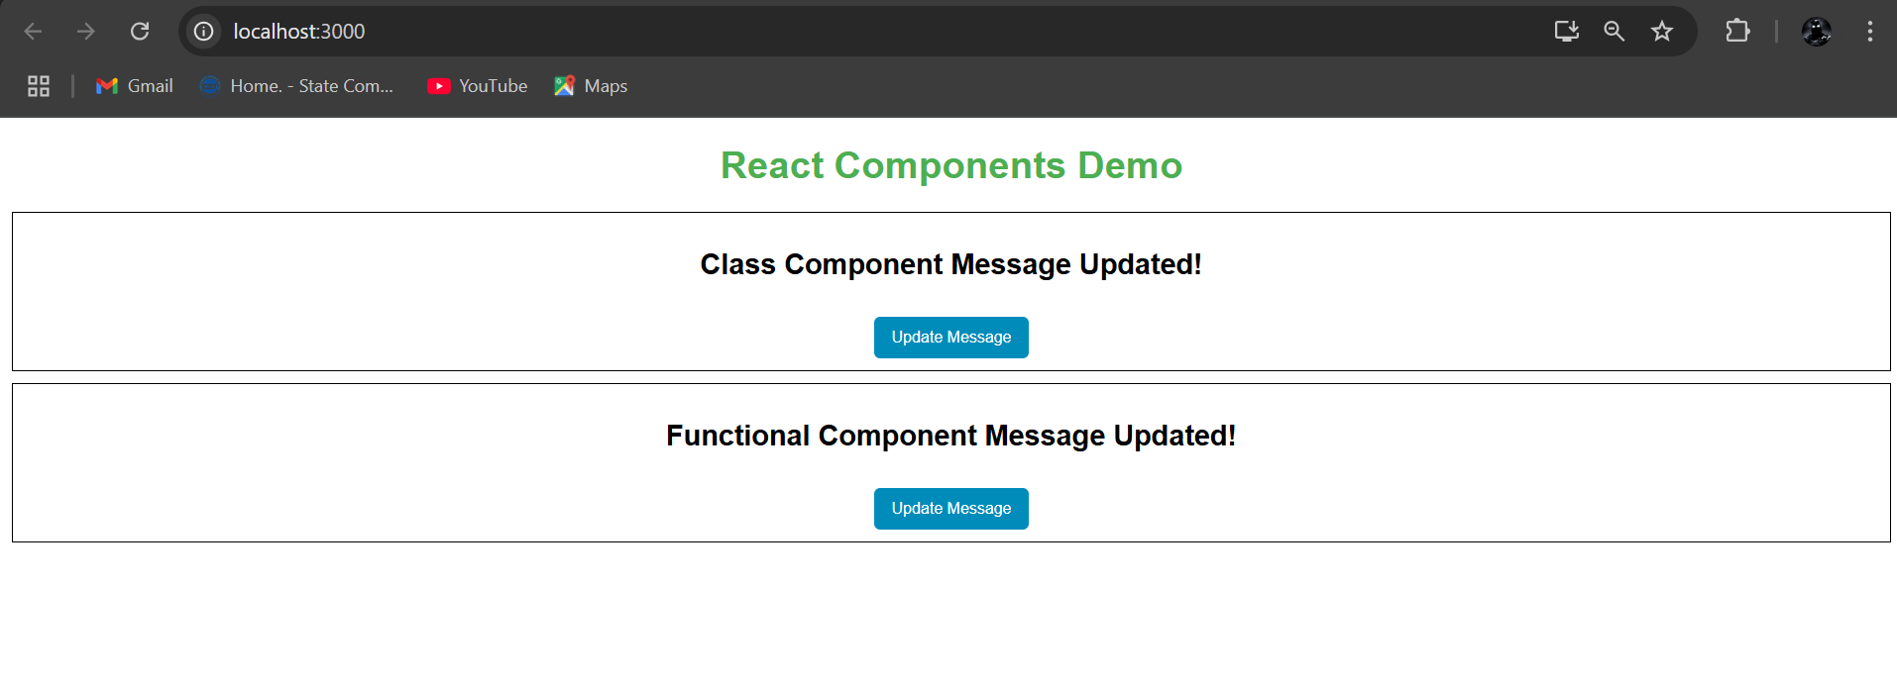

**Q.2) Create and application in ReactJS to import and export the files.**

**Create components folder in src folder and create 4 files in it.**

**Header.js**

import React from 'react';

const Header = () => {

  return (

    <header style={{ background: '#4caf50', color: 'white', padding: '10px' }}>

      <h1>React Import/Export Demo</h1>

    </header>

  );

};

export default Header;

**Footer.js**

import React from 'react';

const Footer = () => {

  return (

    <footer style={{ background: '#f1f1f1', color: '#333', padding: '10px', marginTop: '20px' }}>

      <p>Footer Section &copy; 2024</p>

    </footer>

  );

};

export default Footer;

**Main.js**

import React from 'react';

const Main = () => {

  return (

    <main style={{ padding: '20px' }}>

      <p>Welcome to the React application demonstrating how to import and export components!</p>

    </main>

  );

};

export default Main;

**index.js**

export { default as Header } from './Header';

export { default as Footer } from './Footer';

export { default as Main } from './Main';

**App.js**

import React from 'react';

import './App.css';

import { Header, Footer, Main } from './components';

function App() {

  return (

    <div className="App">

      <Header /> {/* Importing from grouped export */}

      <Main /> {/* Importing from grouped export */}

      <Footer /> {/* Importing from grouped export */}

    </div>

  );

}

export default App;

**index.js**

import React from "react";

import ReactDOM from "react-dom/client";

import "./index.css";

import App from "./App";

import reportWebVitals from "./reportWebVitals";

const root = ReactDOM.createRoot(document.getElementById("root"));

root.render(

  <React.StrictMode>

    <App />

  </React.StrictMode>

);

reportWebVitals();

**App.css**

.App {

  font-family: Arial, sans-serif;

  text-align: center;

  margin: 0;

  padding: 0;

}

header {

  text-align: center;

}

footer {

  position: fixed;

  bottom: 0;

  width: 100%;

}

main {

  min-height: 80vh;

  display: flex;

  align-items: center;

  justify-content: center;

  font-size: 1.2rem;

}

Output :

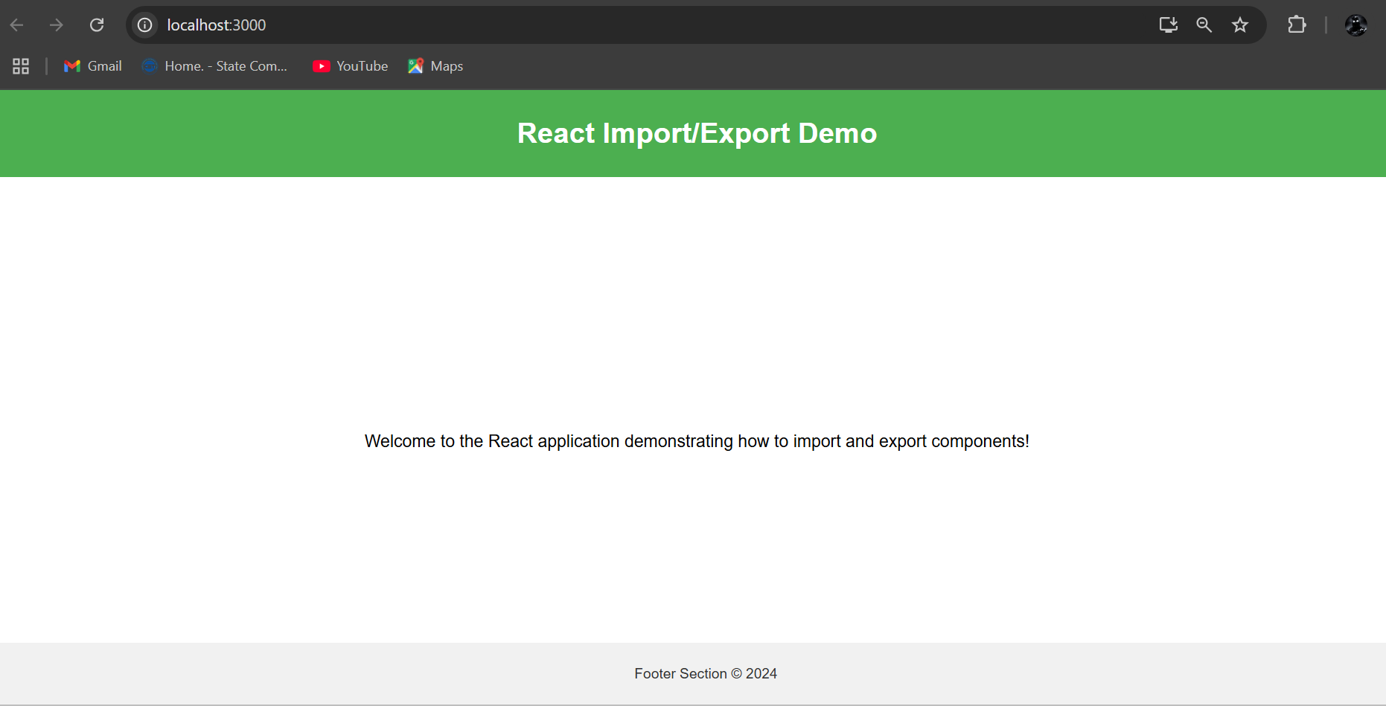

**Q.3) Create an application to implement state and props.**

**Create a component folder inside src folder and add following two files in it.**

**ParentComponent.js**

import React, { useState } from "react";

import ChildComponent from "./ChildComponent";

const ParentComponent = () => {

  const [count, setCount] = useState(0);

  const incrementCount = () => {

    setCount(count + 1);

  };

  return (

    <div style={{ border: "2px solid black", padding: "20px", margin: "20px" }}>

      <h2>Parent Component</h2>

      <p>Count in Parent Component: {count}</p>

      <button onClick={incrementCount}>Increment Count</button>

      {/* Pass count as a prop to the child component */}

      <ChildComponent count={count} />

    </div>

  );

};

export default ParentComponent;

**ChildComponent.js**

import React from 'react';

const ChildComponent = (props) => {

  return (

    <div style={{ border: '2px solid blue', padding: '20px', margin: '20px' }}>

      <h2>Child Component</h2>

      {/* Access the count passed via props */}

      <p>Count received from Parent: {props.count}</p>

    </div>

  );

};

export default ChildComponent;

**App.js**

import React from 'react';

import './App.css';

import ParentComponent from './components/ParentComponent';

function App() {

  return (

    <div className="App">

      <h1>State and Props Demo</h1>

      <ParentComponent />

    </div>

  );

}

export default App;

**index.js**

import React from "react";

import ReactDOM from "react-dom/client";

import "./index.css";

import App from "./App";

import reportWebVitals from "./reportWebVitals";

const root = ReactDOM.createRoot(document.getElementById("root"));

root.render(

  <React.StrictMode>

    <App />

  </React.StrictMode>

);

reportWebVitals();

**App.css**

.App {

  text-align: center;

  font-family: Arial, sans-serif;

  background-color: #f9f9f9;

  padding: 20px;

  min-height: 100vh;

}

button {

  background-color: #008cba;

  color: white;

  border: none;

  padding: 10px 20px;

  margin-top: 10px;

  cursor: pointer;

  border-radius: 5px;

  font-size: 1rem;

}

button:hover {

  background-color: #005f73;

  transform: scale(1.05);

  transition: 0.3s ease;

}

div {

  margin: 10px auto;

  padding: 20px;

  max-width: 500px;

  background-color: #ffffff;

  border-radius: 10px;

  box-shadow: 0px 4px 6px rgba(0, 0, 0, 0.1);

  text-align: left;

}

div > h2 {

  font-size: 1.5rem;

  margin-bottom: 10px;

  color: #333333;

}

div > p {

  font-size: 1.2rem;

  color: #666666;

  line-height: 1.5;

}h1 {

  color: #222222;

  font-size: 2rem;

  margin-bottom: 30px;

  text-transform: uppercase;

  letter-spacing: 2px;

}

Output :

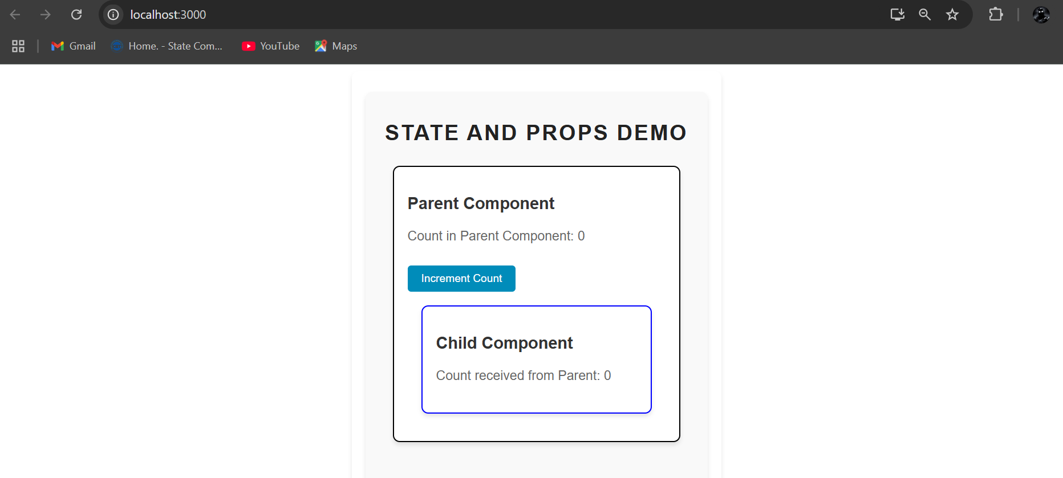

After incrementing the count

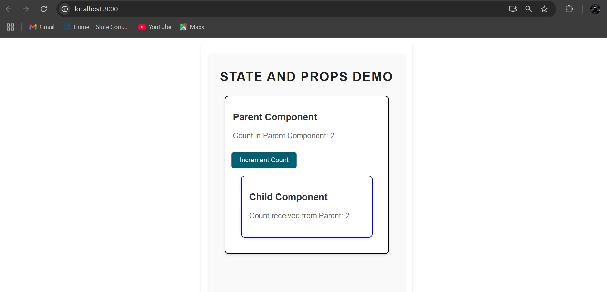

**Q.4) Create an application in ReactJS to use DOM events.**

**Create components folder inside src folder and add**

**EventDemo.js**

import React, { useState } from 'react';

const EventDemo = () => {

  const [bgColor, setBgColor] = useState('#ffffff');

  const [hoverText, setHoverText] = useState('Hover over me!');

  const [inputValue, setInputValue] = useState('');

  const handleButtonClick = () => {

    const randomColor = `#${Math.floor(Math.random() * 16777215).toString(16)}`;

    setBgColor(randomColor);

  };

  const handleMouseOver = () => {

    setHoverText('Mouse is over me!');

  };

  const handleMouseOut = () => {

    setHoverText('Hover over me!');

  };

  const handleInputChange = (event) => {

    setInputValue(event.target.value);

  };

  return (

    <div

      style={{

        backgroundColor: bgColor,

        padding: '20px',

        borderRadius: '10px',

        textAlign: 'center',

        margin: '20px auto',

        maxWidth: '400px',

        boxShadow: '0px 4px 6px rgba(0, 0, 0, 0.1)',

      }}

    >

      <h2>React DOM Events Demo</h2>

      {/* Button click event */}

      <button

        style={{

          padding: '10px 20px',

          backgroundColor: '#4caf50',

          color: 'white',

          border: 'none',

          borderRadius: '5px',

          cursor: 'pointer',

          fontSize: '1rem',

        }}

        onClick={handleButtonClick}

      >

        Change Background Color

      </button>

      <hr style={{ margin: '20px 0' }} />

      {/* Mouse over and out events */}

      <p

        style={{ fontSize: '1.2rem', fontWeight: 'bold', color: '#333' }}

        onMouseOver={handleMouseOver}

        onMouseOut={handleMouseOut}

      >

        {hoverText}

      </p>

      <hr style={{ margin: '20px 0' }} />

      {/* Input change event */}

      <div>

        <input

          type="text"

          placeholder="Type something..."

          value={inputValue}

          onChange={handleInputChange}

          style={{

            padding: '10px',

            borderRadius: '5px',

            border: '1px solid #ccc',

            fontSize: '1rem',

            marginBottom: '10px',

          }}

        />

        <p>Typed text: {inputValue}</p>

      </div>

    </div>

  );

};

export default EventDemo;

**App.js**

import React from 'react';

import './App.css';

import EventDemo from './components/EventDemo';

function App() {

  return (

    <div className="App">

      <h1>React DOM Events Demo</h1>

      <EventDemo />

    </div>

  );

}

export default App;

**App.css**

.App {

  text-align: center;

  font-family: Arial, sans-serif;

  background-color: #f9f9f9;

  padding: 20px;

  min-height: 100vh;

}

h1 {

  font-size: 2rem;

  margin-bottom: 30px;

  color: #333;

  text-transform: uppercase;

  letter-spacing: 1.5px;

}

**index.js**

import React from "react";

import ReactDOM from "react-dom/client";

import "./index.css";

import App from "./App";

import reportWebVitals from "./reportWebVitals";

const root = ReactDOM.createRoot(document.getElementById("root"));

root.render(

  <React.StrictMode>

    <App />

  </React.StrictMode>

);

reportWebVitals();

Output :

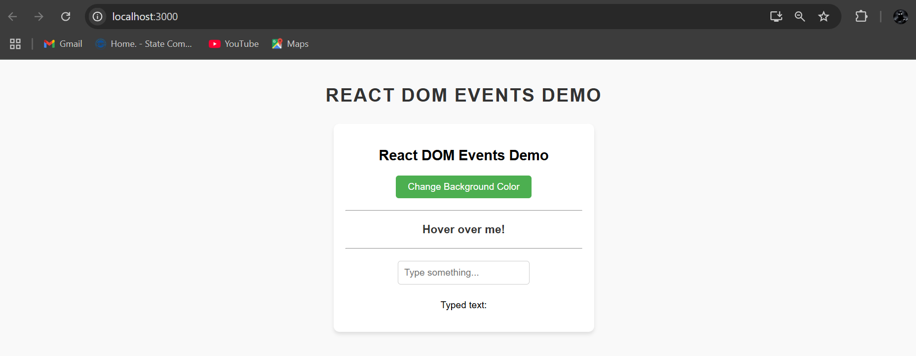

Change background color of the div

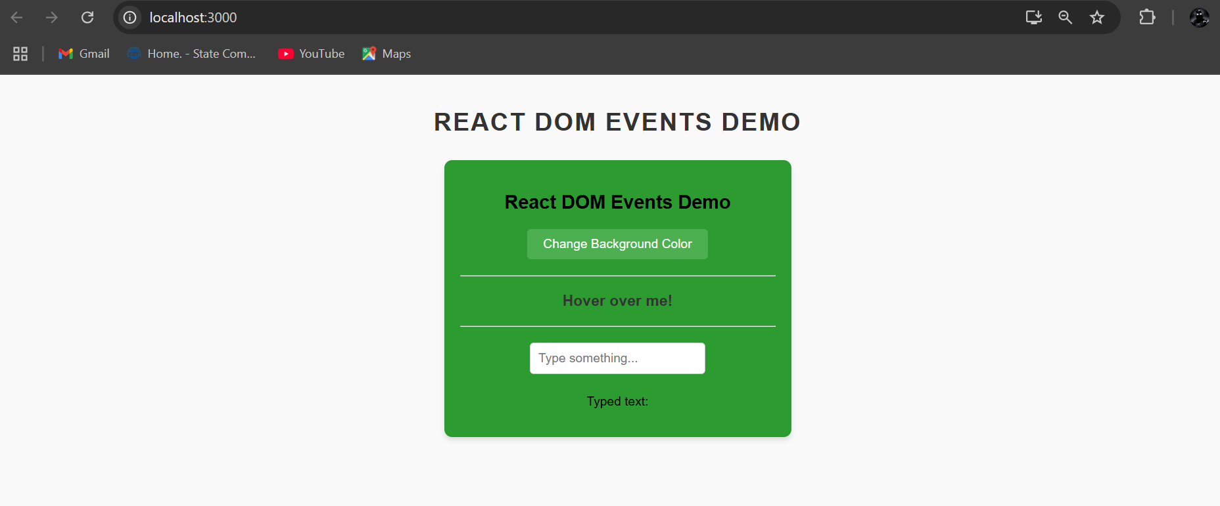

Mouse hovering

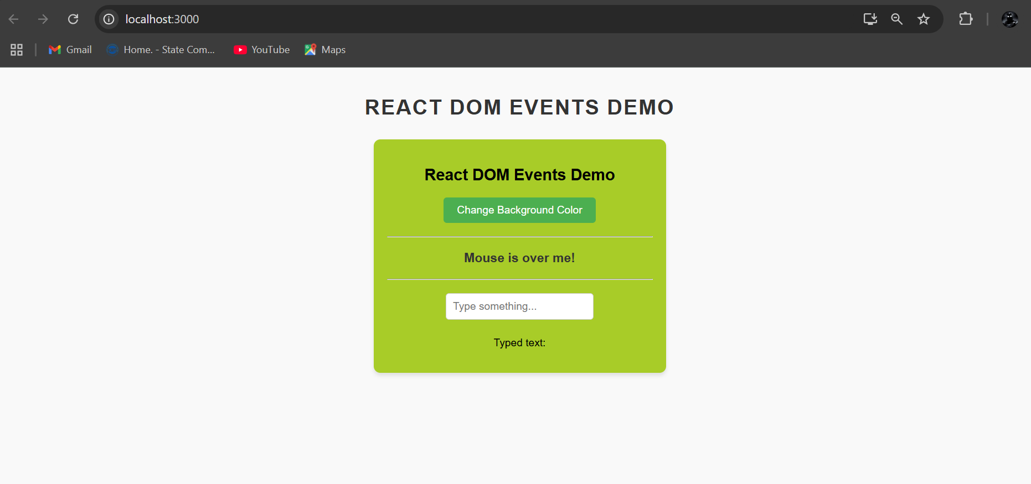

Type something in text area

